A ontologia GO e algumas das suas aplicações

- Explore a página http://geneontology.org/

    - Em baixo, no primeiro painel, encontram uma visão global sobre o que é a ontologia GO (Gene Ontology overview). Explorem e tentem esclarecer alguma dúvida com que tenham ficado da apresentação inicial.
    - Utilizem a seguinte ligação AmiGO 2: Drill-down Browser (geneontology.org) para ter uma visão da estrutura da ontologia GO.
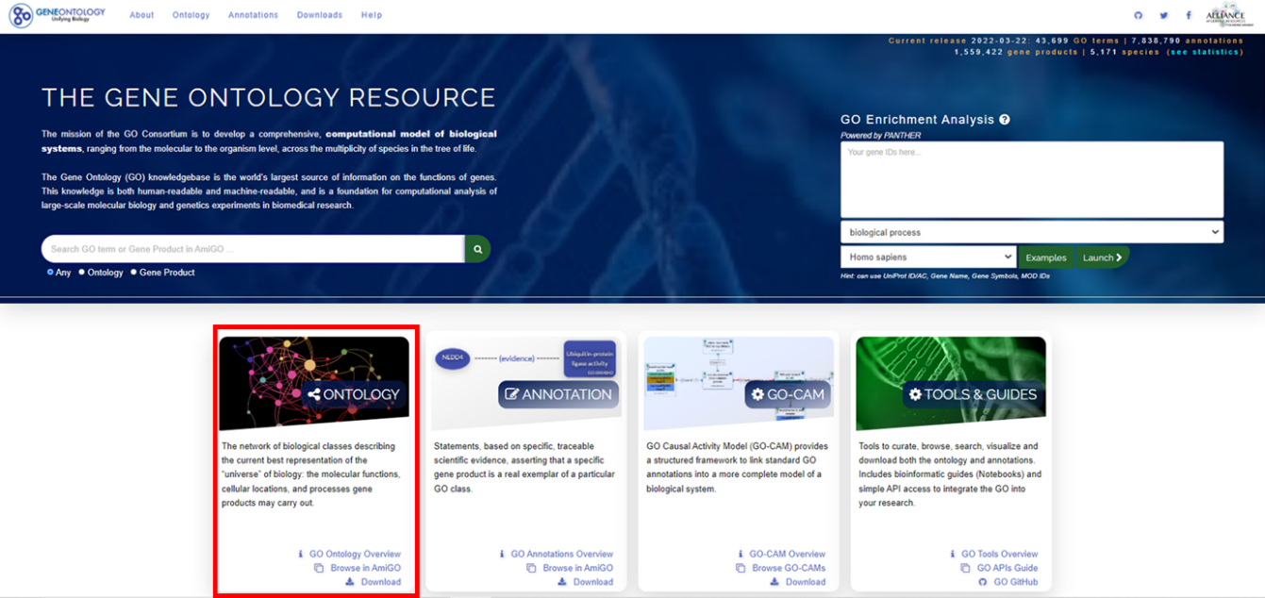
  - No canto superior esquerdo, procurem por produtos génicos, ontologia ou ambos (experimentem por exemplo “metabolism”, “SOD2” ou outro palavra do vosso interesse). Observem o resultado de cada pesquisa. Para cada pesquisa qual é o número de resultados? Que informação está associada a:
    - Termos GO (Termos GO, definição, ontologia, …)
    - Genes/productos génicos (genes/produtos génicos, nome, organismo, …)
    - Anotações (genes/produtos génicos, qualificador da anotação, …)
  - Em baixo, no segundo painel, encontram informação sobre como anotar genes/produto génicos (http://geneontology.org/docs/go-annotations/). Quantos tipos de categorias gerais de códigos de evidência GO existem?
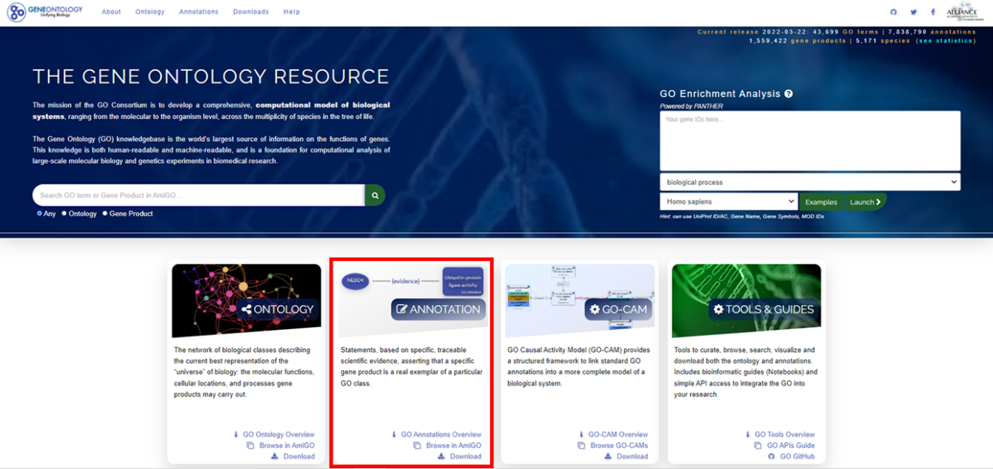
- Pesquisem utilizando QuickGO (https://www.ebi.ac.uk/QuickGO/) por:
  - os termos GO “hydrolase activity”, “cellular response to antibiotic” e “biofilm matrix” e identifiquem:
    - a que ontologia GO pertencem
    - a qual nível da respective ontologia estão
    - quantos termos GO ancestrais directos têm
    - quantos termos GO descendentes directos têm
  - os genes/produtos génicos GSY2, TRX2, CTT1 e identifiquem:
    - se há diferentes organismos com o mesmo gene/produto génico e se têm o mesmo de número de anotações.

- Procedam à anotação GO, justificando a(s) anotação(ões), do gene FPS1 da levedura Saccharomyces cerevisae. Este procedimento deve ser feito exclusivamente a partir da informação contida no sequinte resumo:
A metabolomic analysis using high resolution ¹H NMR spectroscopy coupled with multivariate statistical analysis was used to characterize the alterations in the endo- and exo-metabolome of S. cerevisiae BY4741 during the exponential phase of growth in minimal medium supplemented with different ethanol concentrations (0, 2, 4 and 6% v/v). This study provides evidence that supports the notion that ethanol stress induces reductive stress in yeast cells, which, in turn, appears to be counteracted by the increase in the rate of NAD⁺ regenerating bioreactions. Metabolomics data also shows increased intra- and extra-cellular accumulation of most amino acids and TCA cycle intermediates in yeast cells growing under ethanol stress suggesting a state of overflow metabolism in turn of the pyruvate branch-point. Given its previous implication in ethanol stress resistance in yeast, this study also focused on the effect of the expression of the aquaglyceroporin encoded by FPS1 in the yeast metabolome, in the absence or presence of ethanol stress. The metabolomics data collected herein shows that the deletion of the FPS1 gene in the absence of ethanol stress partially mimics the effect of ethanol stress in the parental strain. Moreover, the results obtained suggest that the reported action of Fps1 in mediating the passive diffusion of glycerol is a key factor in the maintenance of redox balance, an important feature for ethanol stress resistance, and may interfere with the ability of the yeast cell to accumulate trehalose. Overall, the obtained results corroborate the idea that metabolomic approaches may be crucial tools to understand the function and/or the effect of membrane transporters/porins, such as Fps1, and may be an important tool for the clear-cut design of improved process conditions and more robust yeast strains aiming to optimize industrial fermentation performance.

- Procedam à interpretação biológica de um conjunto de dados resultante de uma experiência de RNA-seq (Anexo A).
  - Utilize a ferramenta PANTHER knowledgebase (http://www.pantherdb.org/) para fazer essa análise. No quadro Gene List Analysis: 1. Coloque a lista de genes (Anexo A); 2. Selecione o organismo (S. cerevisiae). 3. Utilize Functional classification viewed in gene list, Functional classification viewed in graphic charts e Statistical overrepresentation test. Com base nos resultados façam uma análise dos dados providenciados.
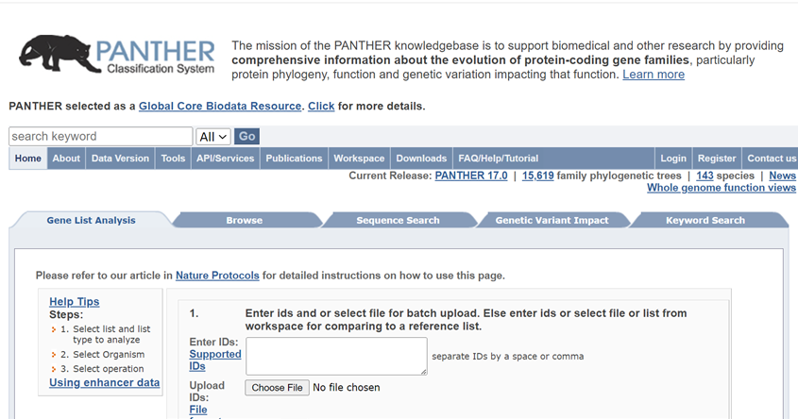

  - Explore a página Database for Annotation, Visualization and Integrated Discovery (DAVID) (https://david.ncifcrf.gov/). 1. Start Analysis; 2. Coloque a lista de genes (Anexo A); 3. Utilize Functional Annotation Table e Functional Annotation Chart. Com base nos resultados façam uma análise dos dados providenciados.
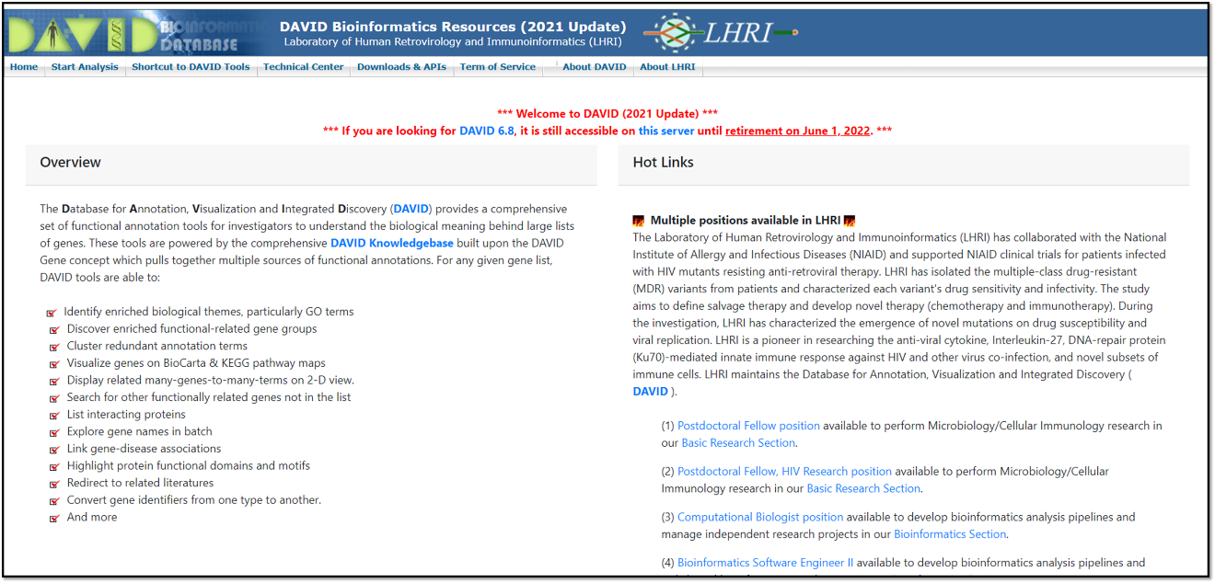

Anexo A

YDR534C
YOR382W
YJR005C-A
YLR237W
YIR019C
YLR004C
YOR383C
YHL047C
YLR411W
YBR092C
YHR094C
YPR124W
YBR032W
YCR020C
YOL055C
YBR240C
YLR214W
YNL141W
YLL053C
YDL049C
YLL052C
YGR159C
YDL184C
YOR294W
YJL122W
YAL059W
YNL112W
YBR034C
YIL064W
YLR073C
YGR035C
YOR381W
YDL205C
YOL080C
YDL133C-A
YDL039C
YIL096C
YFR055W
YLR068W
YPL211W
YKL043W
YPR035W
YGL029W
YBR267W
YLR257W
YOR252W
YKL172W
YKR081C
YLR074C
YBL028C
YJR063W
YDL213C
YPR143W
YNL024C
YDR034C-A
YGR063C
YCL058C
YFR001W
YKR024C
YML056C
YCR087C-A
YLR435W
YPL093W
YDR101C
YIL127C
YOR306C
YNR053C
YOR004W
YGR280C
YLR009W
YOL077C
YLR363W-A
YPL266W
YGR271C-A
YNL175C
YNR015W
YHR216W
YML080W
YPL043W
YBL039C
YML108W
YNL110C
YPL146C
YKL078W
YHR089C
YHR143W-A
YMR319C
YCR047C
YDR465C
YER174C
YHR072W-A
YNL113W
YCL054W
YKL186C
YER137C
YJR010C-A
YKL021C
YMR269W
YMR290C
YOR145C
YLR051C
YAL025C
YNL259C
YPR016C
YBL024W
YHR128W
YIL019W
YLL018C-A
YDR087C
YDR299W
YER126C
YOR272W
YDR399W
YGL099W
YKL009W
YLR196W
YOR101W
YGR103W
YGR123C
YGR245C
YPL245W
YDL208W
YHR052W
YKR060W
YMR014W
YOL124C
YPL012W
YGL078C
YGR145W
YIL008W
YLR186W
YCL059C
YDL153C
YDR365C
YJL033W
YCR024C-A
YDR496C
YER127W
YDR045C
YER145C-A
YHR085W
YNL151C
YDL014W
YHR148W
YJR148W
YLL011W
YNL182C
YCR016W
YDR083W
YIR012W
YNL244C
YDR043C
YDR184C
YDR345C
YER002W
YIR026C
YLR264C-A
YOR021C
YOR095C
YPR069C
YCR051W
YHR191C
YKL099C
YBL054W
YBR088C
YDL201W
YHR081W
YOR224C
YGR187C
YLR017W
YBR191W
YDR514C
YPL193W
YBR252W
YHR169W
YOR182C
YOR253W
YBR142W
YDL031W
YDR021W
YKL082C
YKL096W-A
YDL051W
YNL065W
YNL308C
YPL037C
YPL217C
YPR112C
YCR072C
YDR382W
YLR449W
YER006W
YGR251W
YJR070C
YKL143W
YLR197W
YLR325C
YMR217W
YPR187W
YHR170W
YJL148W
YJR056C
YNL132W
YOR159C
YOR293W
YPL239W
YDR441C
YBR271W
YKL056C
YKL191W
YLR172C
YLR175W
YLR262C-A
YML024W
YBR061C
YHL020C
YHR197W
YKL024C
YOR056C
YAL033W
YGL211W
YMR229C
YEL003W
YFL017W-A
YHR040W
YJL125C
YLR146C
YMR260C
YOL144W
YOR276W
YDL060W
YDL166C
YHR088W
YML022W
YMR131C
YMR239C
YNR024W
YOL125W
YOR143C

